Cross-Connection Site Survey Process
- Authority & Municipal Code Link
- Get active service connections (Meter information from finance) if you have not already done so.
- Ensure you have a good tracking system of sites surveyed – Excel is a good tool if you do not have a software tracking program. You can keep annual data to see running totals.
  - Included in your tracking:
    - Acct#
    - Device/Assembly#
    - Business Name
    - Business Owner
    - Contact First and Last Name
    - Physical Address
    - Type of Assemblies Installed if any
    - Hazard
    - Is it Premise or In-Premise?
    - Make, Model, SN, and Size of Assembly
    - Date Surveyed
    - Compliant – Yes or No
    - Comments
    - Follow up date
    - Final Compliant – Yes or No
    - # Of corrections
    - Date Completed
  - You can easily add columns to track # of accounts surveyed and # of assemblies inspected
  - The more information you include the better tracking for the ASR
    - Example
11 | Total Acct Surveyed | 38 | Total Sites/Assays Surveyed
Grand Total 2020-2023
 |  |  | 2023 Surveyed
58 | 2022 Surveyed | 163 | 2022 Surveyed
164 | 2021 Surveyed | 255 | 2021 Surveyed
158 | 2020 Surveyed | 534 | 2020 Surveyed

    - Correction Tracking
7 | 3 | Total Assemblies Corrections Due
8 | 6 | 2022 Survey Corrections
22 | 21 | 2021 Survey Corrections
30 | 30 | 2020 Survey Corrections
 | 3 | Total Corrections Due

    - Don’t forget to have a good legend

- Verify Site Location – number of buildings and any other meters served on site
  - Map it out (GIS, Google)
  - Irrigation, Domestic, Multiple Meters
  - Get as much information you can with visual online tools (Google Map Street View)
    - Locate meter to obtain as much knowledge prior to site visit
    - Make notes on what you see
- Verify meter information – Size, Location, service addresses, owner information, tenant information especially for multi commercial sites.
- Notification of Water Use Survey
  - The initial letter needs to explain what you are asking for and why and should include:
    - State Requirement– Found in PNWS AWWA, WAC 246-290-490 Element #4
    - City Code Requirement and Responsibility
    - How long this survey will take.
    - Piping plans if available
    - Who they need to contact for more details?
    - Follow up date or Appointment Details – You should require a confirmation of appointment to ensure contact has been made.
  - Keep a copy of the letter to take with you. (People like to claim they did not receive it and were not notified.)
  - Save it in a format you can easily track
    - Example:
Acct# Business Name Type of Letter
4140-09500 CHAINLINE BREWING WATER USE SURVEY NOTIFICATION LETTER
4140-09500 CHAINLINE BREWING WATER USE SURVEY APPOINTMENT LETTER
4140-09500 CHAINLINE BREWING WATER USE SURVEY POST SURVEY LETTER OF COMPLIANCE
4140-09500 CHAINLINE BREWING WATER USE SURVEY POST SURVEY LETTER OF NON-COMPLIANCE

Appointment Letter Example:

Re: Water Use Survey for 520 Kirkland Way (520 Office Building)

Dear Owner/Manager:
To ensure public health, the State of Washington Administrative Code (WAC) 246-290-490 requires the City of Kirkland to protect the public drinking water system from the reverse flow of water, known as backflow, from the consumer’s property back into the public water supply. The city has the responsibility to identify potentially uncontrolled hazardous cross-connections by conducting site surveys of all commercial plumbing systems. To fulfill this responsibility and as part of the city’s comprehensive backflow prevention program we are contacting you to schedule an onsite survey to determine and ensure correct drinking water protections are in place.
Your plumbing system survey is scheduled for
February 17, 2023, at 10:00 am
Please call and confirm your appointment.

If this date and time are not convenient, please contact the Cross-Connection Control Program Specialist at (425) 587-3913 to reschedule.
Plumbing system surveys take approximately one hour (or less) to complete dependent on the size of the facility. The immediate area where water service enters your building and any equipment using water must be accessible for this survey. If you can have an as-built drawing of the water system of your building(s) on hand during the survey it will help answer questions about the location and direction of piping and allow the most accurate assessment as possible. If your site includes multiple businesses, please inform your tenants of the water use survey as we will be entering their space.
Once the survey is completed a letter of non-compliance will be sent detailing corrections if any are needed. To learn more about our backflow prevention program please visit our website at, https://www.kirklandwa.gov/Backflow-Prevention.
If you have any questions, please contact the Cross-Connection Control Program (CCCP) Office. I look forward to working with you. Thank you in advance for helping to protect our public drinking water supply.
Enclosure: City of Kirkland Authority and Municipal Code 21.24.010, Washington Administrative Code (WAC) Department of Health 246-290-490

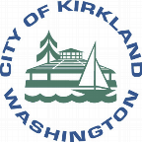
City of Kirkland Authority and Municipal Code:

Authority.
The authority for the City of Kirkland’s Cross Connection Control Program is derived from Chapter 603.0 of the Uniform Plumbing Code (UPC) including its Washington State Amendments as adopted by Kirkland Municipal Code 21.24.010. The UPC refers to WAC 246-290-490 and to the Washington State Department of Health regulations including the AWWA (American Water Works Association) Pacific Northwest’s Sections of “Accepted Procedure and Practice in Cross Connection Control Manual.”

Chapter 21.24.010
UNIFORM PLUMBING CODE
21.24.010 Uniform Plumbing Code adopted.
The 2015 Edition of the Uniform Plumbing Code, as adopted by the State Building Code Council in Chapters 51-56 and 51-57 WAC, as published by the International Association of Plumbing and Mechanical Officials, excluding Chapter 1, “Administration,” is adopted, together with Appendix Chapters A, “Recommended Rules for Sizing the Water Supply System,” B, “Explanatory Notes on Combination Waste and Vent Systems,” C, “Alternate Plumbing Systems,” excluding Sections C5 through C7 of Appendix C, and I, “Installation Standards.” (Ord. 4524 § 69, 2016: Ord. 4410 § 21, 2013: Ord. 4246 § 6 (part), 2010: Ord. 4099 § 7 (part), 2007: Ord. 3946 § 1 (part), 2004)

The City of Kirkland Municipal Code 21.24.010 be viewed in its entirety at:
https://www.codepublishing.com/WA/Kirkland/.

Washington Administrative Code (WAC) Department of Health 246-290-490:
Cross-connection control.
- Applicability, purpose, and responsibility.
  - All community water systems shall comply with the cross-connection control requirements specified in this section.
(c) The purpose of the purveyor's cross-connection control program shall be to protect the public water system, as defined in WAC 246-290-010, from contamination via cross-connections.
- General program requirements.
(f) The purveyor shall ensure that cross-connections between the distribution system and a consumer's water system are eliminated or controlled by the installation of an approved backflow preventer commensurate with the degree of hazard.
(i) Premises isolation as defined in WAC 246-290-010; or
(ii)246-290-010 (188) "Premises isolation" means a method of protecting a public water system by installation of approved air gaps or approved backflow prevention assemblies at or near the service connection or alternative location acceptable to the purveyor to isolate the consumer's water system from the purveyor's distribution system.
- The purveyor shall take appropriate corrective action as authorized by the legal instrument required by subsection (3)(b) of this section, when:
  - A cross-connection exists that is not controlled commensurate to the degree of hazard assessed by the purveyor; or
  - A consumer fails to comply with the purveyor's requirements regarding the installation, inspection, testing, maintenance, or repair of approved backflow preventers required by this chapter.
    - The purveyor's corrective action may include, but is not limited to:
      - Denying or discontinuing water service to a consumer's premises until the cross-connection hazard is eliminated or controlled to the satisfaction of the purveyor;
      - Requiring the consumer to install an approved backflow preventer for premises isolation commensurate with the degree of hazard; or
      - The purveyor installing an approved backflow preventer for premises isolation commensurate with the degree of hazard.
- Approved backflow preventers.
  - The purveyor shall ensure that all backflow prevention assemblies relied upon by the purveyor are models included on the current list of backflow prevention assemblies approved for use in Washington State. The current approved assemblies list is available from the department upon request.
- Approved backflow preventer inspection and testing.
  - For backflow preventers that protect the public water system, the purveyor shall ensure that:
    - A CCS inspects backflow preventer installations to ensure that protection is provided commensurate with the assessed degree of hazard;

- You may need to follow up if nobody has confirmed the appointment.
  - It’s a great idea when confirming your appointment, you get the full name and phone number of person you are meeting and meeting location.
  - Make sure you request a person who is familiar with the facility, plumbing system, and equipment processes.
  - Explain what they should expect from this survey.
- Preparing for the site survey (BE PREPARED)
  - Take a copy of the appointment letter with you
  - Prepare your survey form in advance. (There are many types of forms available. You can use one already provided by USC Manual Cross-Connection Control, IAPMO, electronic survey systems, or create your own.
  - COK Example - Commercial

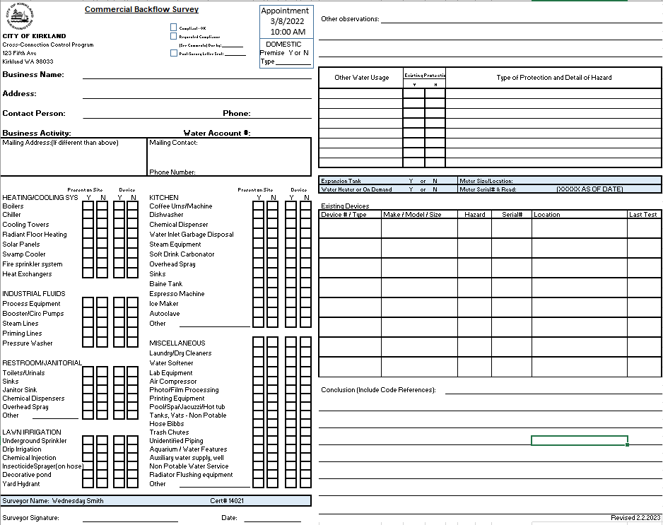

  - IAPMO Example
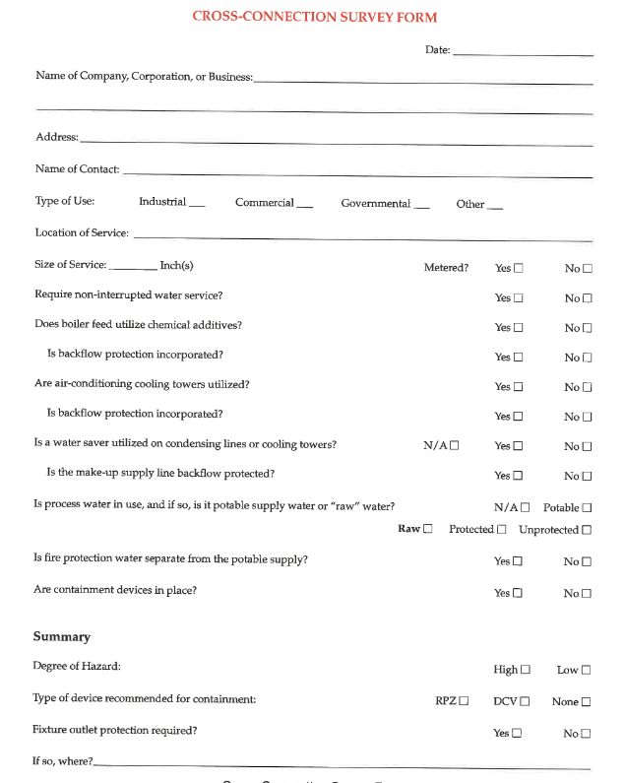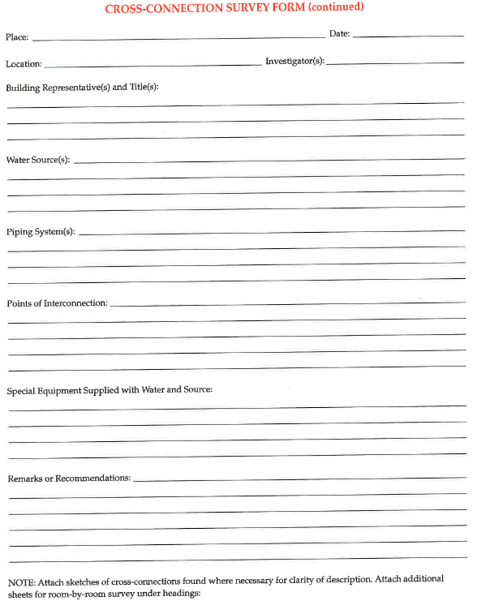
  - USC Example
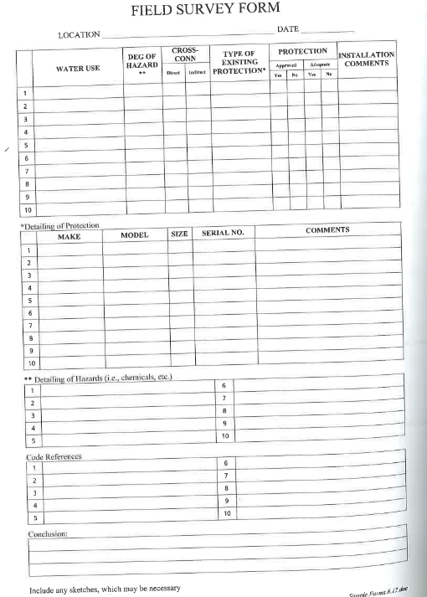

- Survey Example-Residential
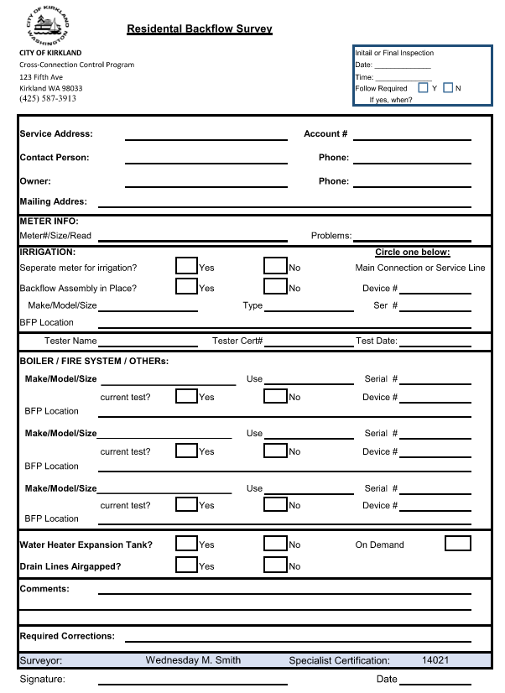

- Bring a flashlight, clipboard, forms, soap stone (for revealing SN on assemblies), small and long screwdriver for opening lids, gloves, face masks (medical facilities) and camera.
    - Photos should include assembly installation, assembly name plate (make model & SN), water using equipment including model information for equipment you are not familiar with. This will also you to research the item to see if additional protection is needed.
- You should have reference materials with you. Examples include:
    - List of Table 13 Link
    - List of Hazards with protection requirements
      - With fixture isolations
      - PNWS – AWWA Cross-Connection Control Manual
        - Page 168 Chapter 5
    - Janitors sink protection information Link & Mop Sink Best Practices
    - Chemical Dispenser & AVB use information Link
    - Installation standards (spec sheets)
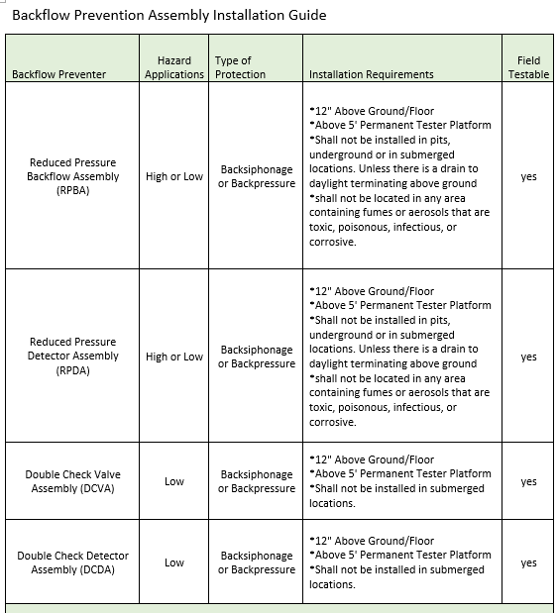

Backflow Prevention Assembly Installation Guide (Continued)
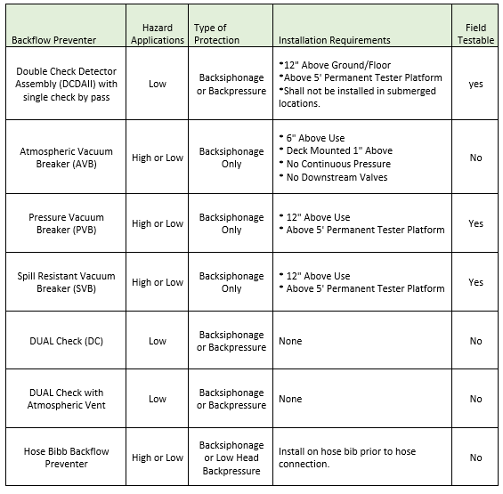
- As you perform the survey, Rule #1 is to take your time. If the time is not convenient or you feel they are rushing you around, reschedule the appointment. It’s important to do a thorough survey and working with your community members will go along way.

- You should always begin your survey at the meter. This will allow you to verify the meter serial number and installation of any backflows for premise including dedicated irrigation lines. You may find more than one meter. Document everything you see including the condition of the meter.

- It’s also best to allow the person you are walking with to determine the route of the survey for larger complexes. They have the most knowledge of how the property is set up. Before you behind your walk through go through your form and explain to them what you are looking for and that you may be asking the same questions multiple times depending on how many buildings your visiting.
  - Have one form per building or business so you can quickly keep everything together and organized.
- What you need to know?
  - How is the water being used?
  - Do you have existing protection?
  - What other water using equipment do they have that was not asked on the form?
  - Verify – contact person, mailing address and follow up phone number.
- You may need to get on a dirty floor, behind a hot oven, or under a sink to verify the make, model and serial number so be prepared.

- It’s best to have two people during a survey but it okay if you do not. If you are the only one with the customer, talk them through the process as you walk. Educate them during the survey so if you find compliance issues, they will be able to understand what needs to be done before they receive the post survey letter.

- Take pictures of everything and make sure you have your photos dated.

- Be sure to thank them for their time and give them a time frame on your follow up/post survey letter.

POST SURVEY:
- Document your tracking log, database, and files
  - Save site pictures with details (Device# Hazard SN., etc.) Link

- Prepare compliance letter; Owner and tenant Link
  - Include:
    - photos if possible (Make is simple)
    - CC: all who need to know.
      - Public Works Manager
      - AHJ – Planning & Development
      - Inspector
      - Owner/Tenant

- Set up a tracking system by date for easy access and follow up. Like a tickler file.

