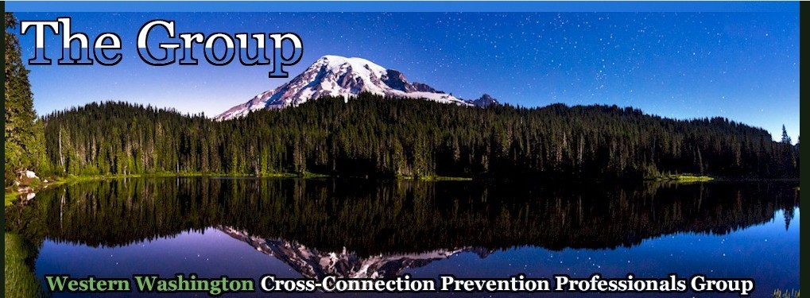

July 2023 NEWSLETTER

The Group
P.O. Box 75223 Seattle, WA 98175
www.backflowgroup.org

OFFICERS

Chair: Jeff Kobylk City of Edmonds 425 771 0235
Jeff.kobylk@edmondswa.gov

Vice Chair: Wednesday Smith Batgirl Backflow Testing 206 948 0484

batgirlbackflowtesting@gmail.com
Treasurer: Dennis McLaughlin | BAT-Retired | 206 364 9643
d.p.mclaughlin@outlook.com
Secretary: Kathy Caldwell | City of Snohomish | 360 282 3165
caldwell@snohomishwa.gov
thegroup2021@outlook.com
Past Chair: Mick Holte | City of Renton | 425 430 7207
mholte@rentonwa.gov
Webmaster: Paul Molisani  paul@ecosconnect.com | EcosConnect | 503 830 0171

Greetings all,

The group was excited to be invited to tour the Climate Pledge Arena mechanical rooms during the July meeting. It was really interesting to see a site that has domestic water, rainwater, and reuse water all in one place.

The attendees were Chair Jeff Kobylk, Vice Chair Wednesday Smith, Justin Hawley from the City of Kirkland Building Inspection, Dominic McLaughlin from the City of Seattle, John Anderson and Todd Freeman with Sammamish Plateau Water, Tyler Buss, Tyler Rouse and Mike Lee from the City of Bellingham, Indee Girven from Kitsap PUD, Tim Cantwell and DeLynn Erickson from Woodinville Water, and Megan Brech with Washington Certification Services.

The main areas we visited included: (Pictures at the end)

- Domestic Water Entry Room – Potable Water
- Fire Entry Room – Potable Water
- Outside Irrigation Connection Points – Potable Water
- Inside Irrigation – Non-Potable (Reclaimed Water) Condenser Room
- Ice Room – Non-Potable Rainwater Catchment System

We were able to take some pictures so please enjoy! I can’t wait to see where we go next year.

Next month, we are having our annual group picnic. It will be held on August 16, 2023, at Hill Park in Snohomish County. We are planning to have BBQ catered so please RSVP with Kathy Caldwell by 8/8/23 at caldwell@snohomishwa.gov if you are planning to attend so we can plan for food accordingly.
We look forward in seeing you there.

Picnic Address:
Hill Park
1610 Park Ave
Snohomish WA 98290.

Finally, the October Seminar Agenda is finally complete. Please find attached the agenda information and registration form. Don’t wait sign up today!

Have a good day!
Kathy Caldwell-Sec.
Wednesday Smith-Vice Chair

The Group Field Trip 2023
Climate Pledge Arena

